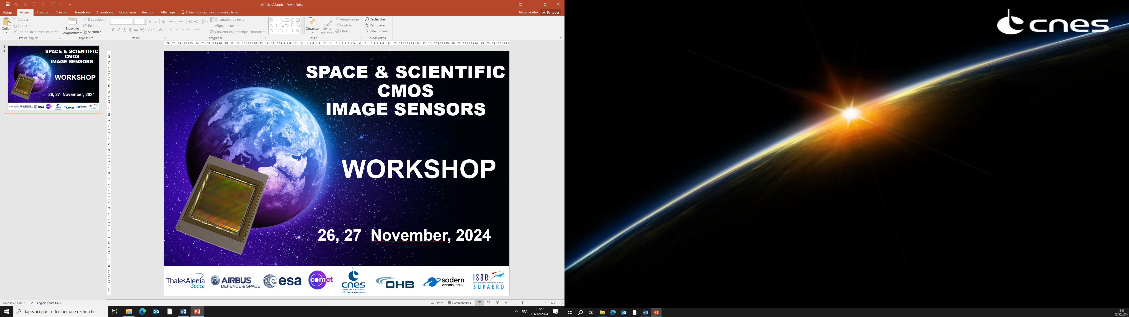

**DIAGORA  
Centre de Congrès et d'Exposition. 150, rue Pierre Gilles de Gennes  
31670 TOULOUSE – LABEGE**



**SLIDES**

|  |  |  |  |  |  |  |  |  |  |  |  |  |  |  |  |  |  |  |  |  |  |  |  |  |  |  |  |  |  |  |  |  |  |  |  |  |  |  |  |  |  |  |  |  |  |  |  |  |  |  |  |  |  |  |  |  |  |  |  |  |  |  |  |  |  |  |  |  |  |  |  |  |  |  |  |  |  |  |  |  |  |  |  |  |  |  |  |  |  |  |  |  |  |  |  |  |  |  |  |  |  |  |  |  |  |  |  |  |  |  |  |  |  |  |  |  |  |  |  |  |  |  |  |  |  |  |  |  |  |  |  |  |  |  |  |  |
| --- | --- | --- | --- | --- | --- | --- | --- | --- | --- | --- | --- | --- | --- | --- | --- | --- | --- | --- | --- | --- | --- | --- | --- | --- | --- | --- | --- | --- | --- | --- | --- | --- | --- | --- | --- | --- | --- | --- | --- | --- | --- | --- | --- | --- | --- | --- | --- | --- | --- | --- | --- | --- | --- | --- | --- | --- | --- | --- | --- | --- | --- | --- | --- | --- | --- | --- | --- | --- | --- | --- | --- | --- | --- | --- | --- | --- | --- | --- | --- | --- | --- | --- | --- | --- | --- | --- | --- | --- | --- | --- | --- | --- | --- | --- | --- | --- | --- | --- | --- | --- | --- | --- | --- | --- | --- | --- | --- | --- | --- | --- | --- | --- | --- | --- | --- | --- | --- | --- | --- | --- | --- | --- | --- | --- | --- | --- | --- | --- | --- | --- | --- | --- | --- | --- | --- | --- |
| |  |  |  |  |  |  |  |  |  |  |  |  |  |  |  |  |  |  |  |  |  |  |  |  |  |  |  |  |  |  |  |  |  |  |  |  |  |  |  |  |  |  |  |  |  |  |  |  |  |  |  |  |  |  |  |  |  |  |  |  |  |  |  |  |  |  |  |  |  |  |  |  |  |  |  |  |  |  |  |  |  |  |  |  |  |  |  |  |  |  |  |  |  |  |  |  |  |  |  |  |  |  |  |  |  |  |  |  |  |  |  |  |  |  |  |  |  |  |  |  |  |  |  |  |  |  |  |  |  |  |  |  |  |  |  |  | | --- | --- | --- | --- | --- | --- | --- | --- | --- | --- | --- | --- | --- | --- | --- | --- | --- | --- | --- | --- | --- | --- | --- | --- | --- | --- | --- | --- | --- | --- | --- | --- | --- | --- | --- | --- | --- | --- | --- | --- | --- | --- | --- | --- | --- | --- | --- | --- | --- | --- | --- | --- | --- | --- | --- | --- | --- | --- | --- | --- | --- | --- | --- | --- | --- | --- | --- | --- | --- | --- | --- | --- | --- | --- | --- | --- | --- | --- | --- | --- | --- | --- | --- | --- | --- | --- | --- | --- | --- | --- | --- | --- | --- | --- | --- | --- | --- | --- | --- | --- | --- | --- | --- | --- | --- | --- | --- | --- | --- | --- | --- | --- | --- | --- | --- | --- | --- | --- | --- | --- | --- | --- | --- | --- | --- | --- | --- | --- | --- | --- | --- | --- | --- | --- | --- | --- | | **Wednesday 27th November**   |  |  |  | | --- | --- | --- | |  | **Author & Title** |  | | **09:30** | **TUTORIAL** |  | |  | **The Timepix Family of Hybrid Pixel Detectors and Applications in Measurement of Space Radiation** | |  | *R. Ballabriga, M. Campbell, , X. Llopart – CERN, Geneva, Switzerland* | |  | *C. Granja - ADVACAM, Prague, Czech Republic* | | **SESSION** | *CMOS for Time stamping* |  | |  | *Chair: O. Marcelot ISAE-SUPAERO* |  | |  |  |  | | **10:20** | **Development of a LIDAR Receiver Unit: LIROC- PICOTDC** |  | |  | *T. Saleem, S. Ahmad, A. Hadar, F. Perez, J. Fleury – WEEROC, Villebon sur Yvette, France A. Panglosse, A. Materne, CNES, Toulouse, France* | |  |  |  | | **10:40** | **FLAMES: A Flash LidAr iMagE Sensor chip for Rendez-vous and Landing applications** |  | |  | *J. Vermeiren, V. Schuddinck, G. Cai, B. De Schepper, B. Dierick, J. Basteleus – Caeleste, Mechelen Belgium K. Haugholt, H. Torring, B. Nossum – SINTEF, Norway M. Somann – ESA-ESTEC, The Netherlands* | |  |  |  | | **11:00** | **Towards Characterizing Spatial Contrast Transfer in Event-Based Cameras** |  | |  | *L. Baehr, D. Joubert, F. Le Goff – Prophesee, France* | |  | *L. Baehr, M. Estribeau, V. Goiffon – ISAE-SUPAERO, Toulouse, France* | |  |  |  | | **SESSION** | *Architectures* |  | |  | *Chair: S. Demiguel Thales Alenia Space* |  | |  |  |  | | **11:50** | **Design and characterisation of a full-frame low-noise HDR 8μm, 12Mpixel, 34fps CMOS image sensor for industrial, medical, space and scientific applications** |  | |  | *M. Sannino, C. Bauza-Alcover, A. Font-Garcia, R. Gifreu-Pons, M. Gargallo, M. Giulioni, K. Latif Akhtar,O. Llados-Cos, A. Molla-Garcia, V. Palmero-Arans, A. Scott, R. Turchetta, A. Bofill-Petit – IMASENIC, Barcelona, Spain D. Uzbelger Feldman – Real Time Imaging Technologies, Charlotte USA E. Simons – Blur Product Development, Cary, USA*  *A. Birman – Tower Semiconductor, Migdal Haemek, Israel* | |  |  |  | | **12:10** | **CMOS TDI Detectors for High Resolution Imaging** |  | |  | *S. Sanjeevi, V. Arkesteijn, L. Wu, C. Hong, HJ. Lee, G. Rodrigues, M. Miethig, R. Ghannoum, P. Donegan, S. Kullar – Teledyne DALSA, Waterloo, CANADA* | |  |  |  | | **12:30** | **Infrared FPA Readout System with the NIRCA MkII ASIC** |  | |  | *A.Fagerland Haavik, T. Ostmoe, A. Hasanbegovic, D. Meier, B. Samadpoor Rikan, T. Nesjo, HK. Otnes Berge, A. Dadashi, S. Azman, J. Talebi, JE. Holter, P. Oya, G. Maehlum – IDEAS, Oslo, Norway* | |  |  |  | | **12:50** | **5 μm Pixel and Column ADC for 1 MGy Radiation Tolerant CMOS Image Sensor** |  | |  | *I. Hafizh, P. Santos, P. Leroux, and G. Meynants – KU Leuven, Belgium* | |  |  |  | |  |  |  | |  |  |  | | **SESSION** | *CMOS for Scientific Applications* |  | |  | *Chair: A. Vriet Sodern* |  | |  |  |  | | **14:20** | **CMOS X-ray Sensors for Future Space Astronomy and Planetary Science** |  | |  | *A.Holland, T. Buggey, C. Crews, D. Hall, J. Ivory, C. Townsend-Rose, K. Stefanov -  Centre for Electronic Imaging, The Open University, UK* | |  |  |  | | **14:40** | **CMOS Sensors for Scientific Imaging at the CEI** |  | |  | *K. Stefanov, T. Buggey, C. Crews, D. Hall, A. Holland, J. Ivory, M. Patel, M. Prest, J. Skottfelt, , P. Smith - Centre for Electronic Imaging, The Open University,* UK | |  |  |  | | **15:00** | **The ARCADIA Depleted Monolithic Active Pixel: X-ray characterization and imaging applications** |  | |  | *S. Ciarlantini, C. Bonini, D. Chiappara, P. Giubilato, S. Mattiazzo, C.*  *Pantouvakis, M. Rignanese, and A. Zingaretti – University of Padova, Italy - Istituto Nazionale di Fisica Nucleare (INFN), Padova section, Italy* | |  |  |  | |  |  |  | | **15:20** | **Fast & low read noise CMOS camera for planetary science and astrophysics** |  | |  | *MM. Roth - Deutsches Zentrum für Astrophysik (DZA), Görlitz Leibniz-Institut für Astrophysik Potsdam (AIP) Universität Potsdam, Germany* | | |